**E2E Test Framework**

1. **Configuration Details required for Setup:**

The cdap-e2e is a framework and google-cloud/src/e2e-test is a plugin specific repo, which contains a plugin specific test and step definition.

1. cdap-e2e-tests
2. google-cloud

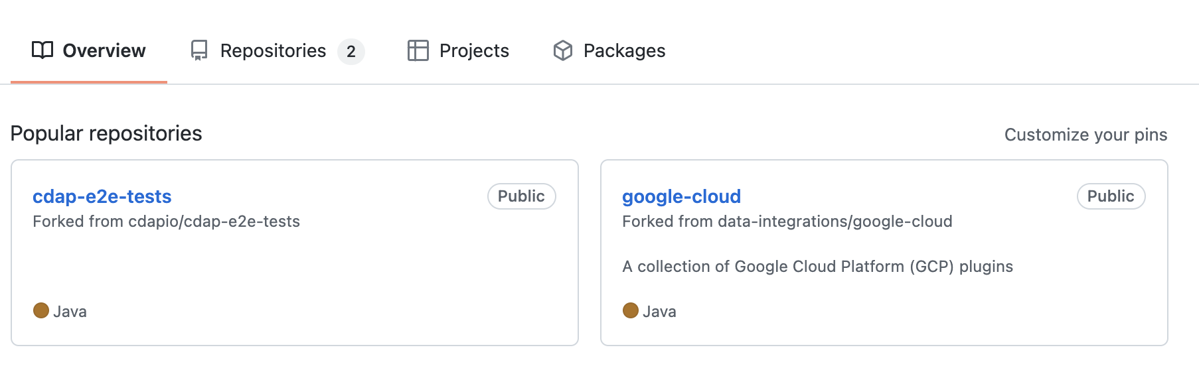

1. **Clone the cdap-e2e-tests framework of develop branch, which contains the common helper classes:**

* Open IntelliJ IDEA tool.
* From the File menu select **New** and choose **Project From Version Control** option as shown below:

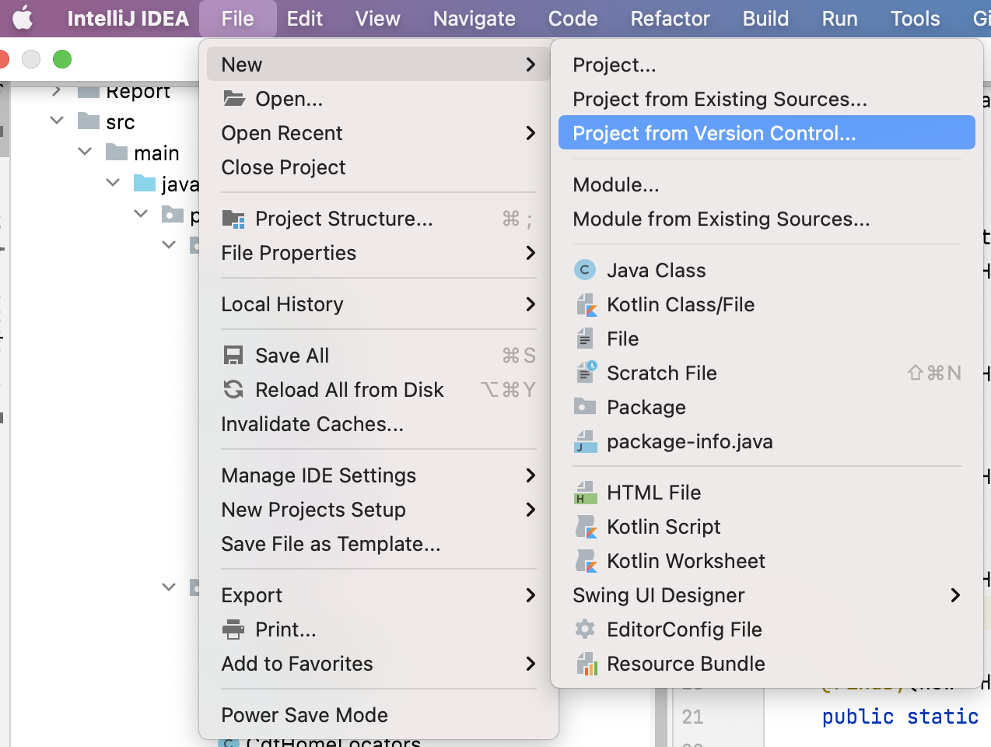

* Provide the Github URL in the URL and click on **Clone** to clone the project.

**URL**: *https://github.com/cdapio/cdap-e2e-tests*

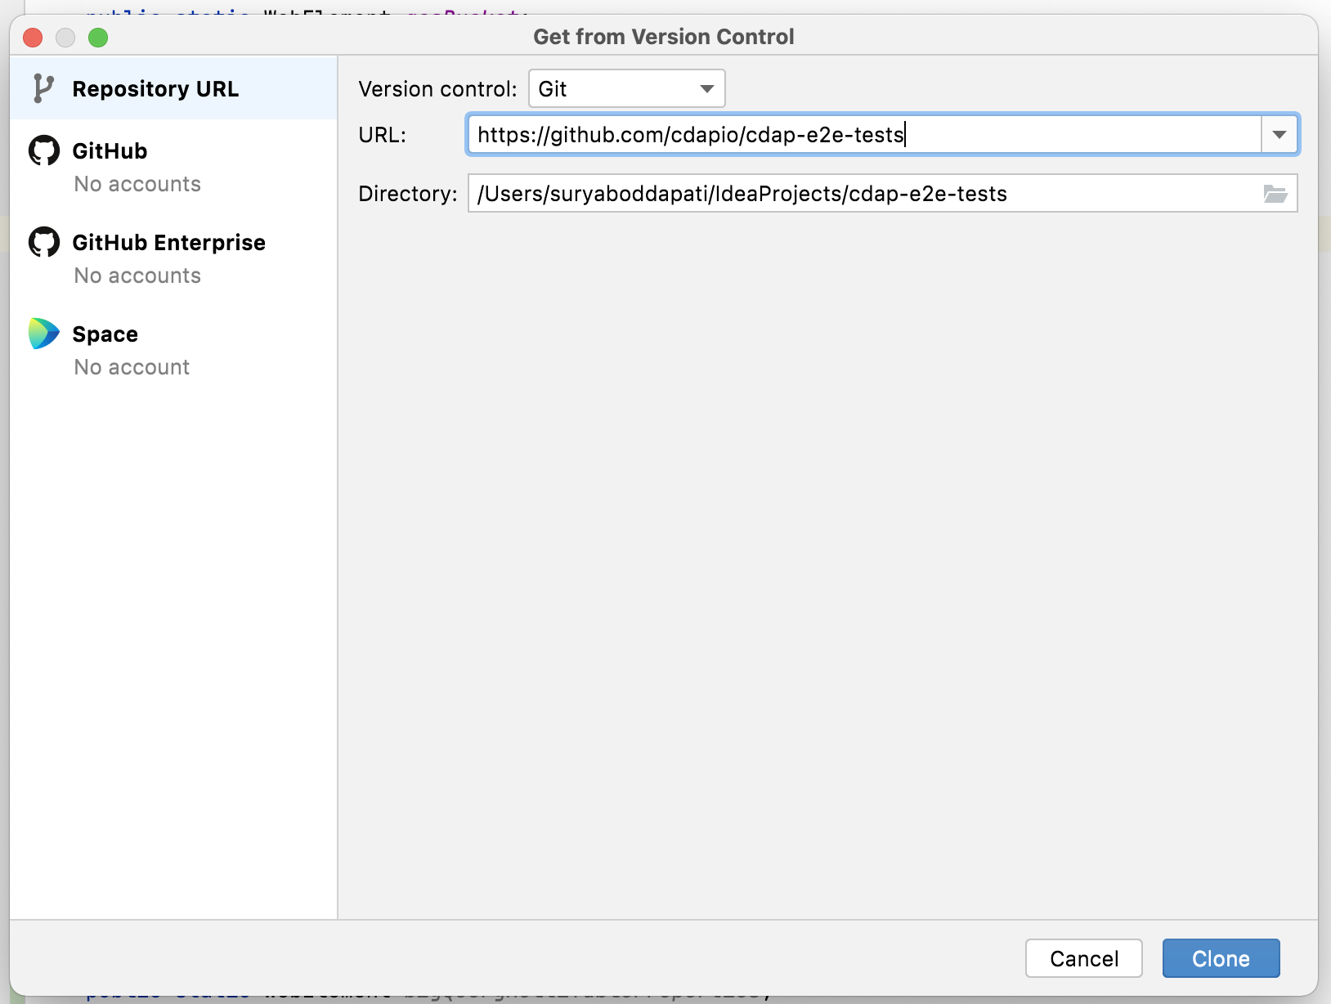

1. Provide the required details in the ConnectionParameters.properties file that is common for all the connectors.

CDFURL=http://localhost:11011/pipelines/ns/default/studio

1. All the configuration details need to be present in this file.

**Please find the list of connectors along with their specific configuration details:-**

**GCS**: When we have GCS as source, we have to provide the path of the file located in the GCS bucket which already exists. All the different file formats paths used for testing are configured here, it also includes the GCP credentials.

***#GCSbucket- Provide the bucket path***

*For example, gs://<bucket>/path/to/directory/*

***#project-id***

***project-id= XXXXX***

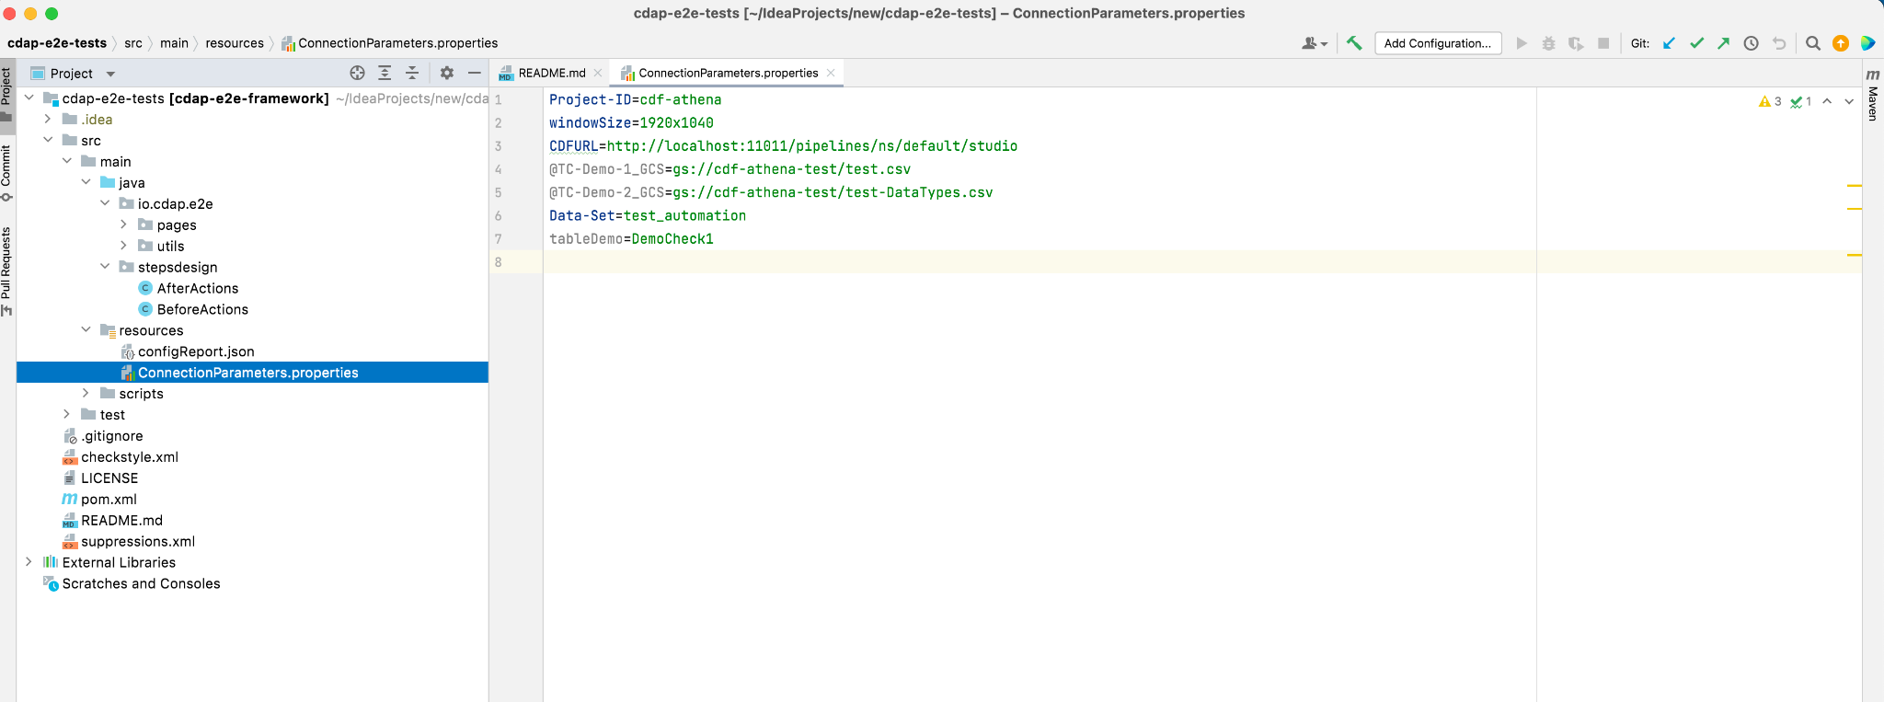

1. **Add Plugin specific Actions and Locators:**

Open cdap-e2e-tests framework. Add the following under pages:

1. **Add Locators**

It contains the Web Element identification, Xpath of the respective fields of the plugin in properties.

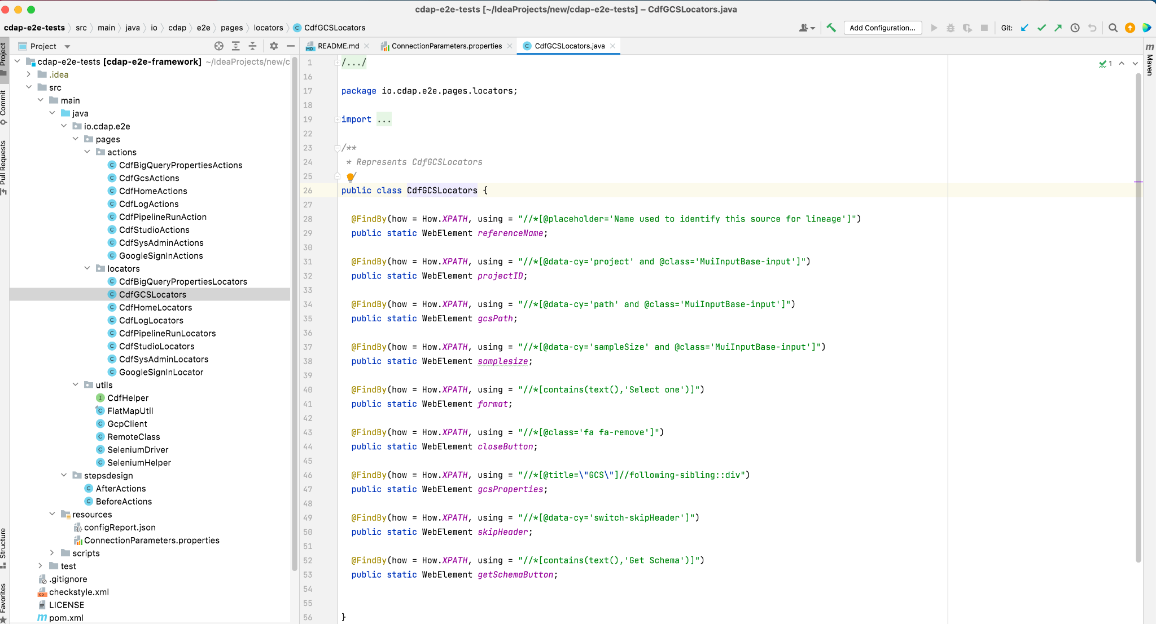

1. **Add Actions**

It contains locator actions of what action needs to be performed on the respective field of the plugin in properties.

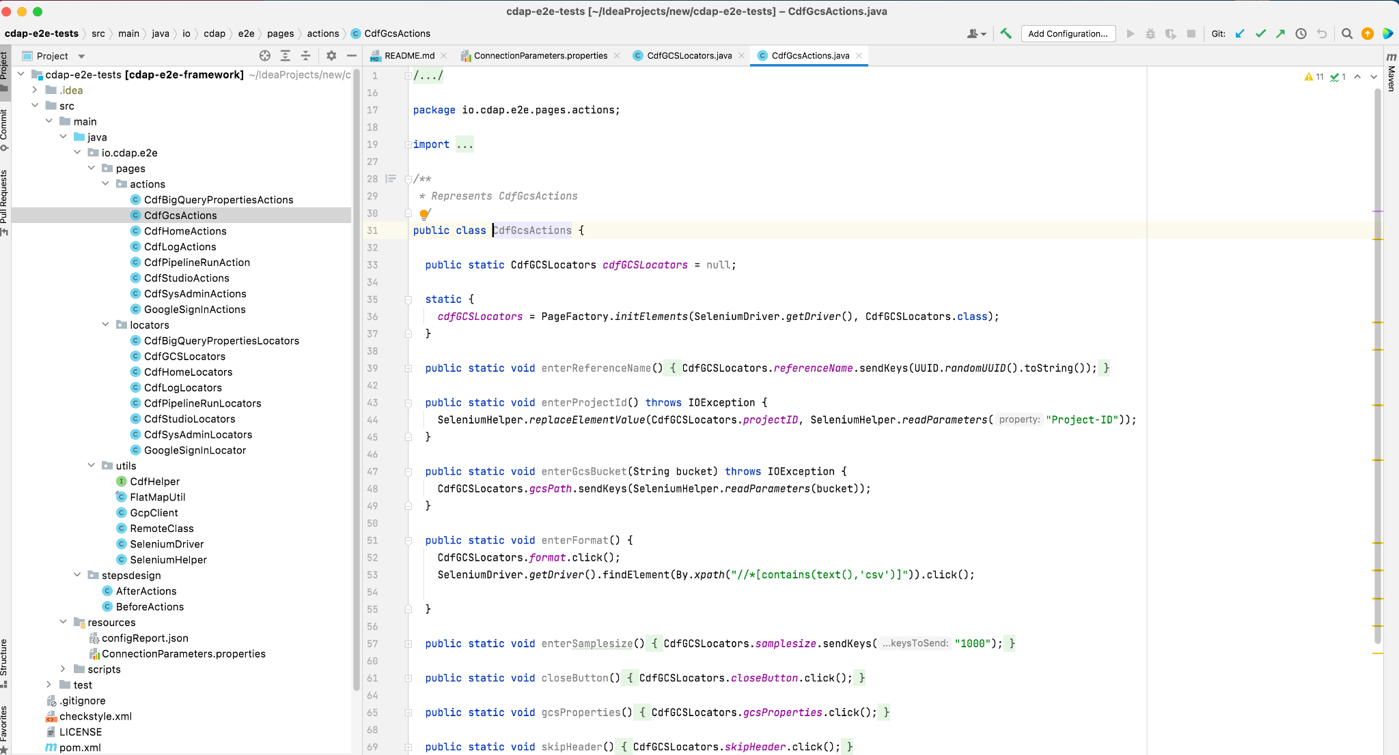

* It contains the Util classes example cdfHelper class which contains common methods related to CDF and can implement them in step definitions, and SeleniumHelper class which contains common java functions.
* After taking the latest pull every time, in the terminal enter ***maven clean install*** command to compile. Create a JAR and inject the dependencies in integration project.

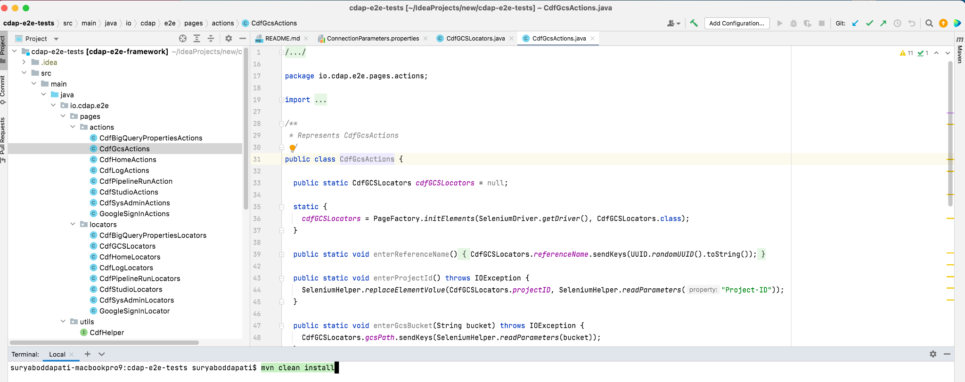

1. **Clone the google-cloud, data-integration framework which contains the plugin specific details:**

* Now clone the google-cloud and data-integration project.
* From the File menu select **New** and choose **Project From Version Control** option as shown below.



* Provide the Github URL in the URL. Click **Clone** to clone the project.

**URL**: *https://github.com/data-integrations/google-cloud*

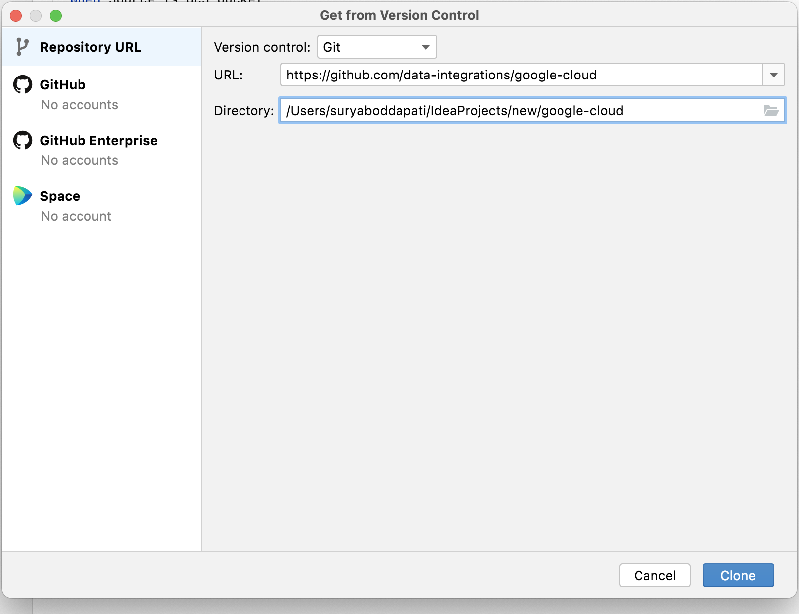

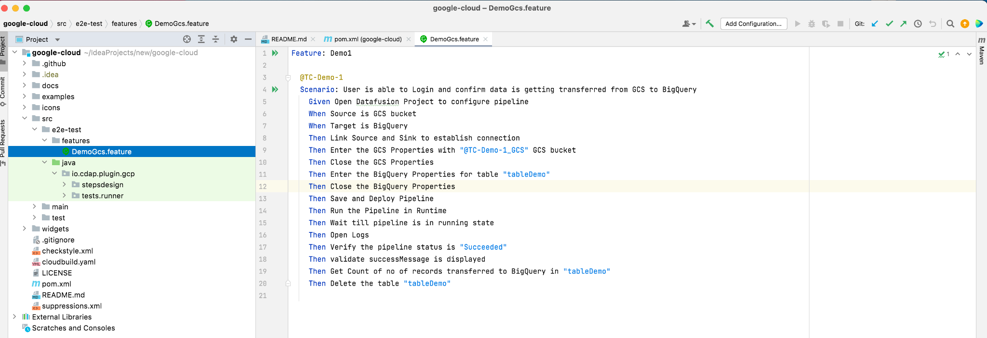

* All the details will be under the e2e-test folder structure below.

***Path for Feature files***- src/e2e-test/features

***Path for Step design***- src/e2e-test/java/io.cdap.plugin/pluginname/stepsdesign

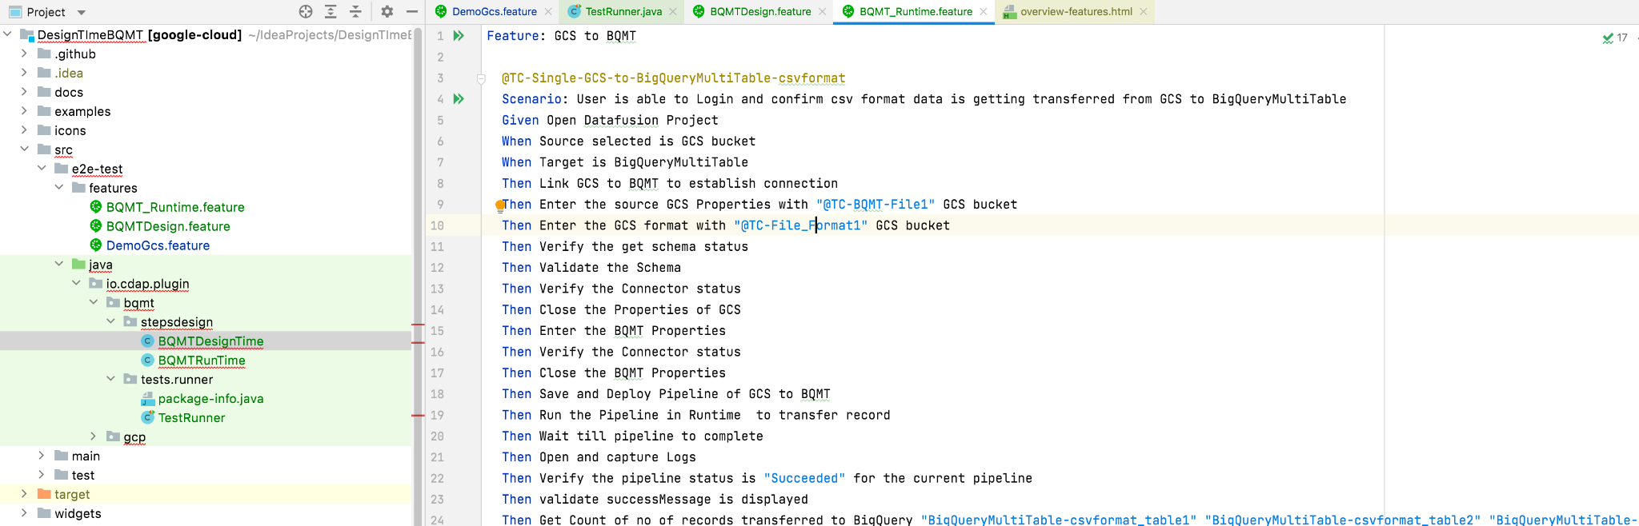

* It should contain the plugin specific feature files and step definition.

***Add Feature***:

Feature file contains high level description of the Test Scenarios in simple language.

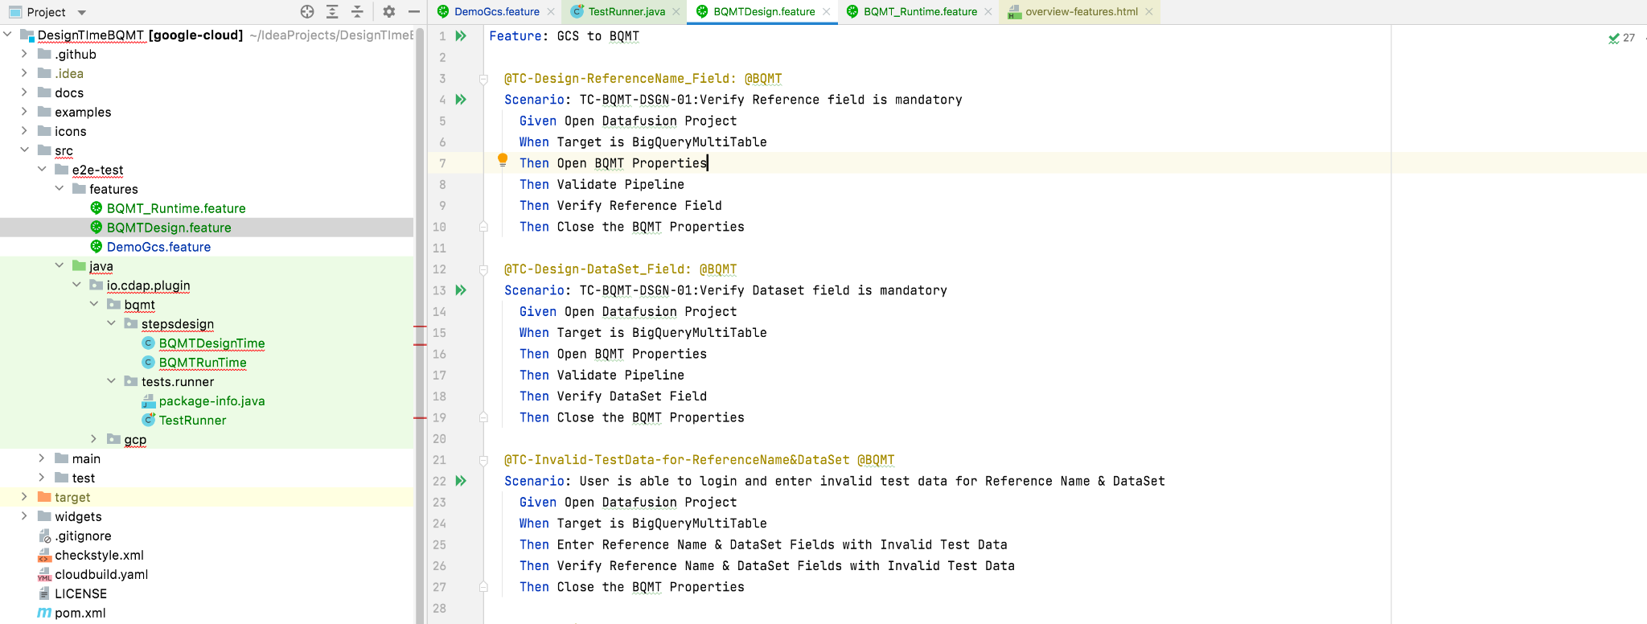

***Add Step definition***:

Step definition maps the test case steps in the feature files(introduced by Given/When/Then) to code. It executes the steps on Application Under Test and checks the outcomes against expected results.

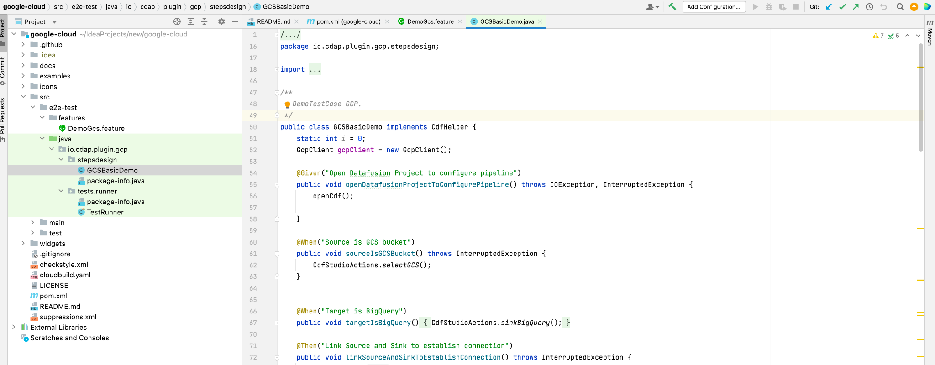

* Select Maven and verify if the e2e tests profile is selected. Click **reload all maven projects to reload the dependencies**.

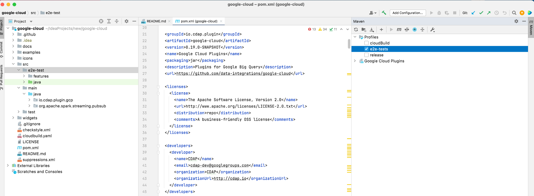

* Edit the configurations for cloud service for Test runner to maintain the service account. The service account key has permission to access and connect to the GCP client, which is used for creation and validation.

GOOGLE_APPLICATION_CREDENTIALS=key [Path of JSON service key]

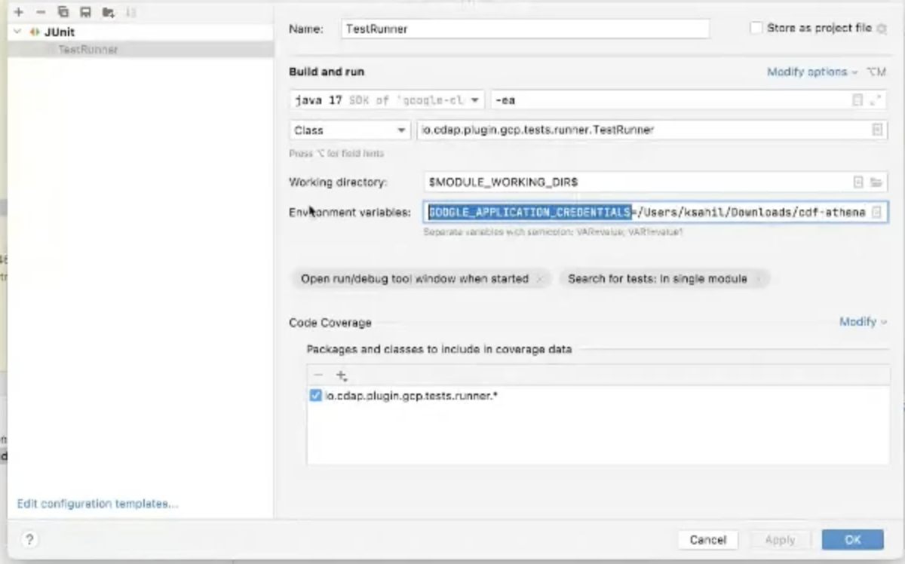

* To run the profile enter ***mvn verify -P e2e-tests*** command in terminal.

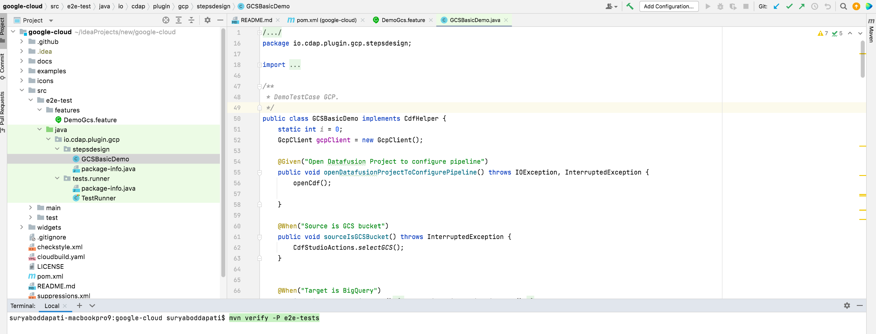

* After the build is successful, then the target folder will be created automatically like below.

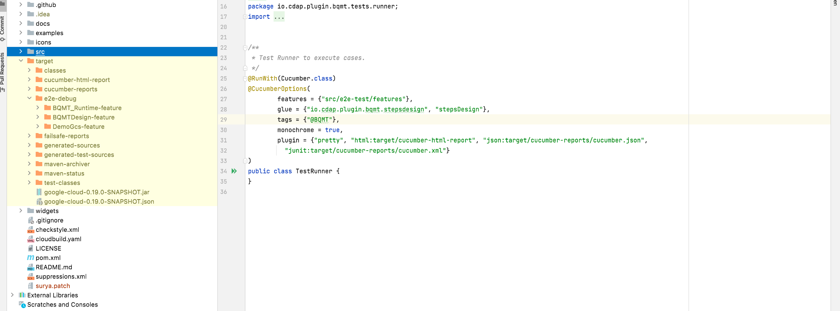

* After execution of the pipeline the logs are captured according to the scenario name.

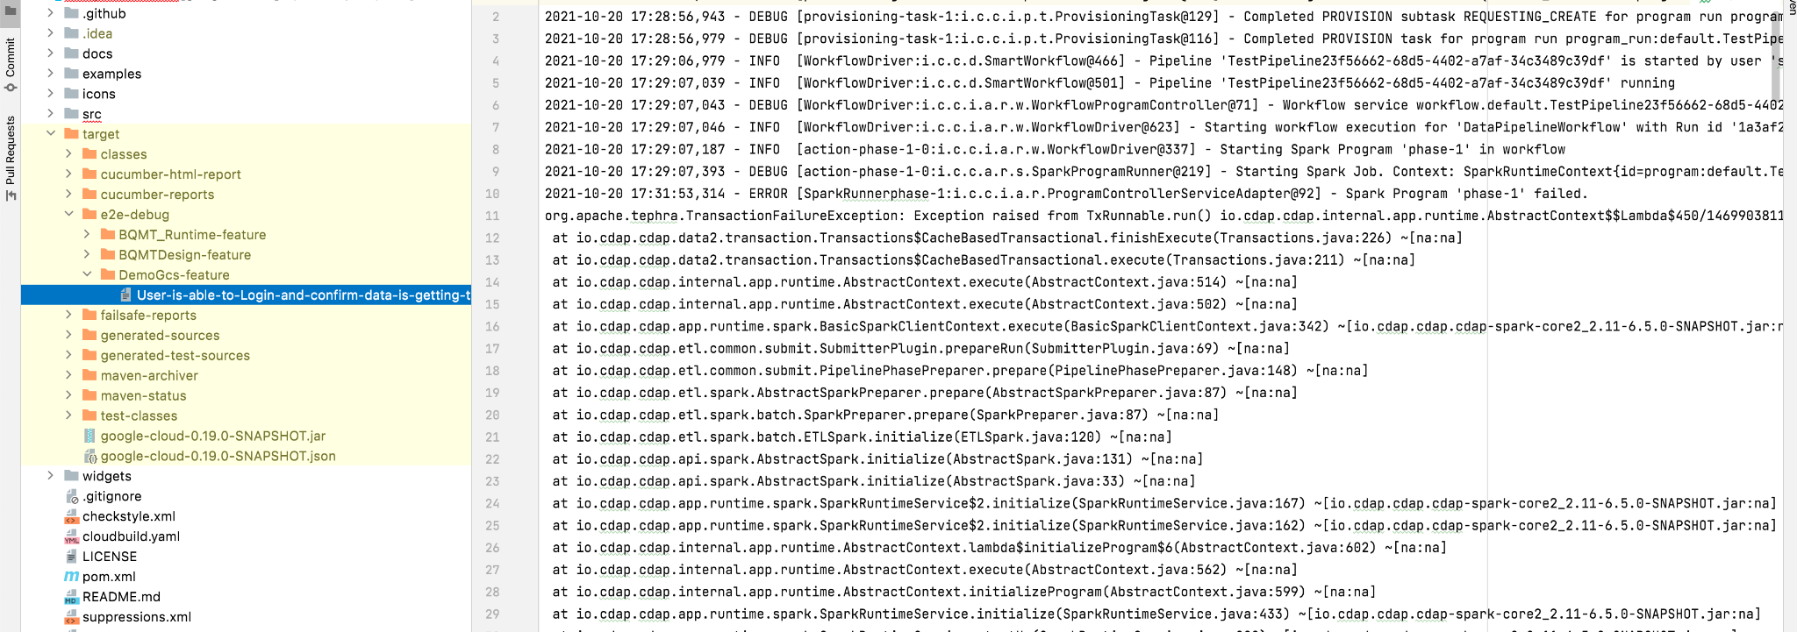

1. **Test Reports Generated**
2. Reports generated show the test script results in case of Pass and Fail.

Different types of reports are saved within the project location at the below path.

/cdap-e2e-tests/target/cucumber-reports/advanced-reports/cucumber-html-reports/overview-failures.html

1. We can get different reports at Feature level, Tags (each step with screenshot), Steps, Statistics and Failures.

**Features:** It contains all the status of the test cases at feature level execution.

**Steps :** It contains all the status related to the steps executed, showing different statuses Passed, Failed, Stopped, Pending, Undefined and Total steps.

**Scenarios :** It contains the status of each scenario executed.

**Pass:**

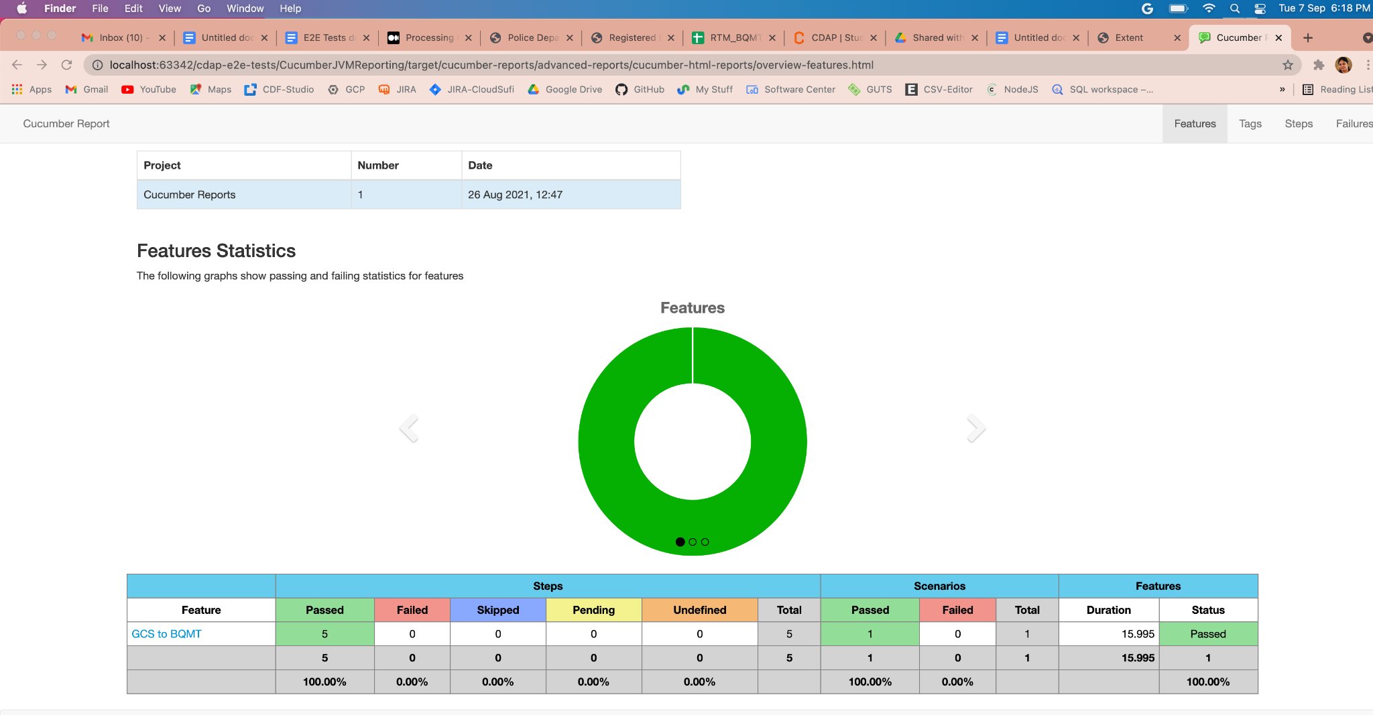

**Fail:**

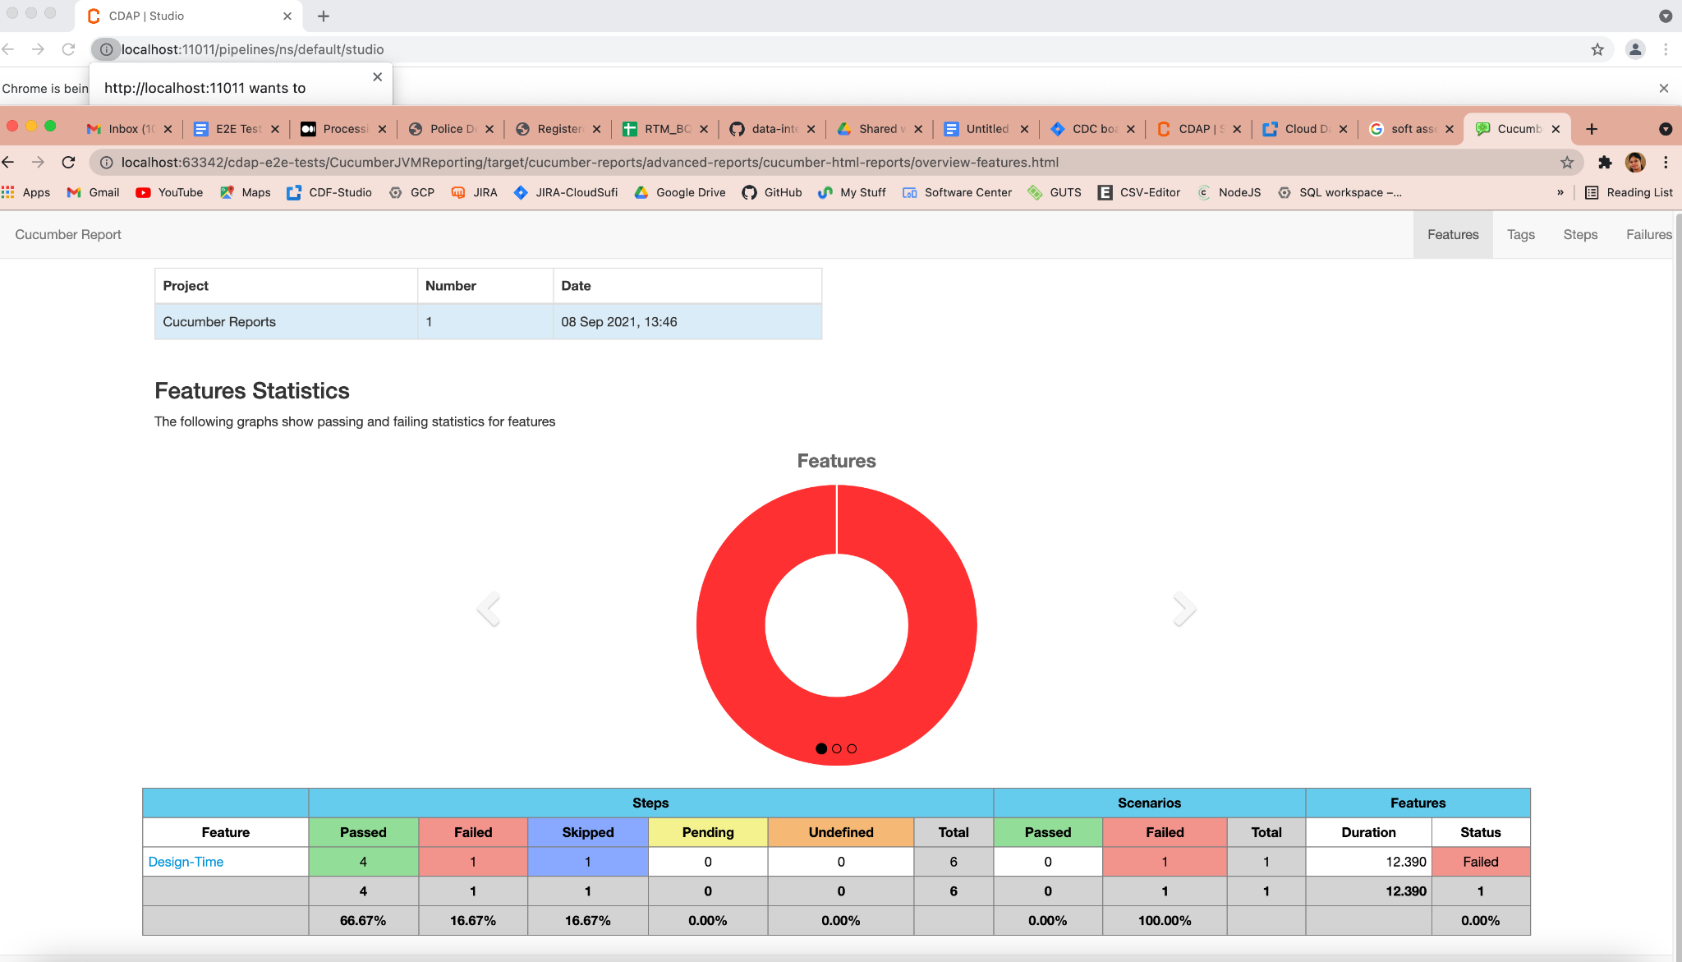

1. We can see the screenshot of each step as shown in the screenshot below.

/cdap-e2e-tests/target/cucumber-reports/advanced-reports/cucumber-html-reports/overview-tags.html

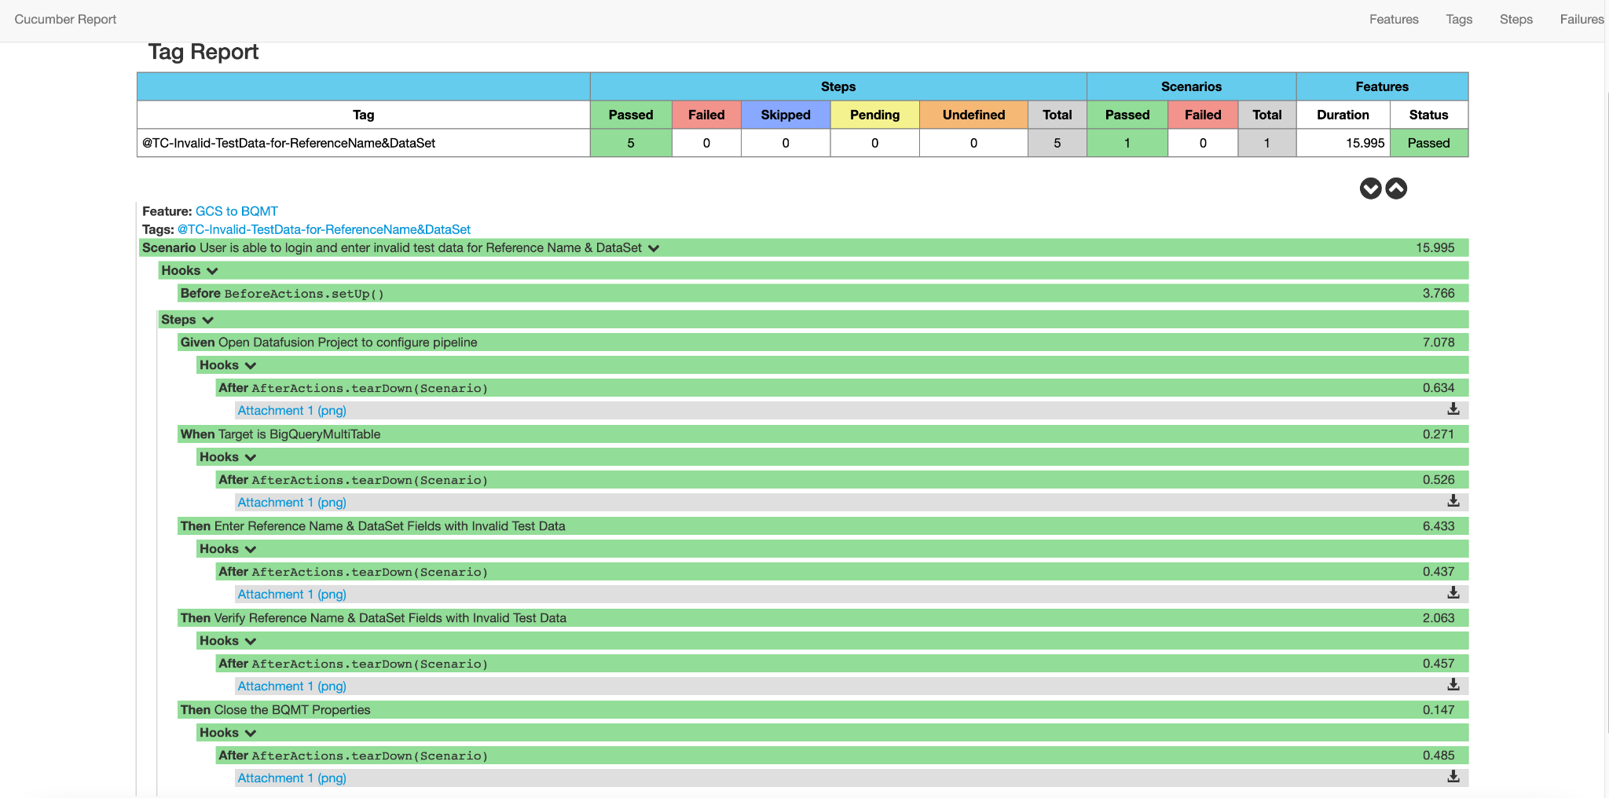

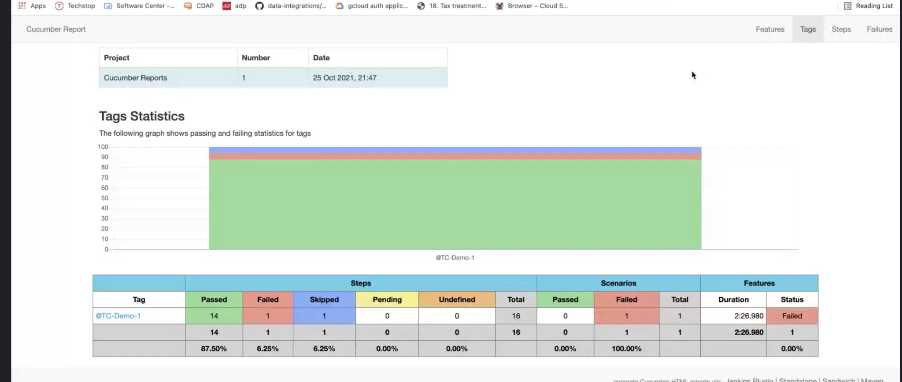

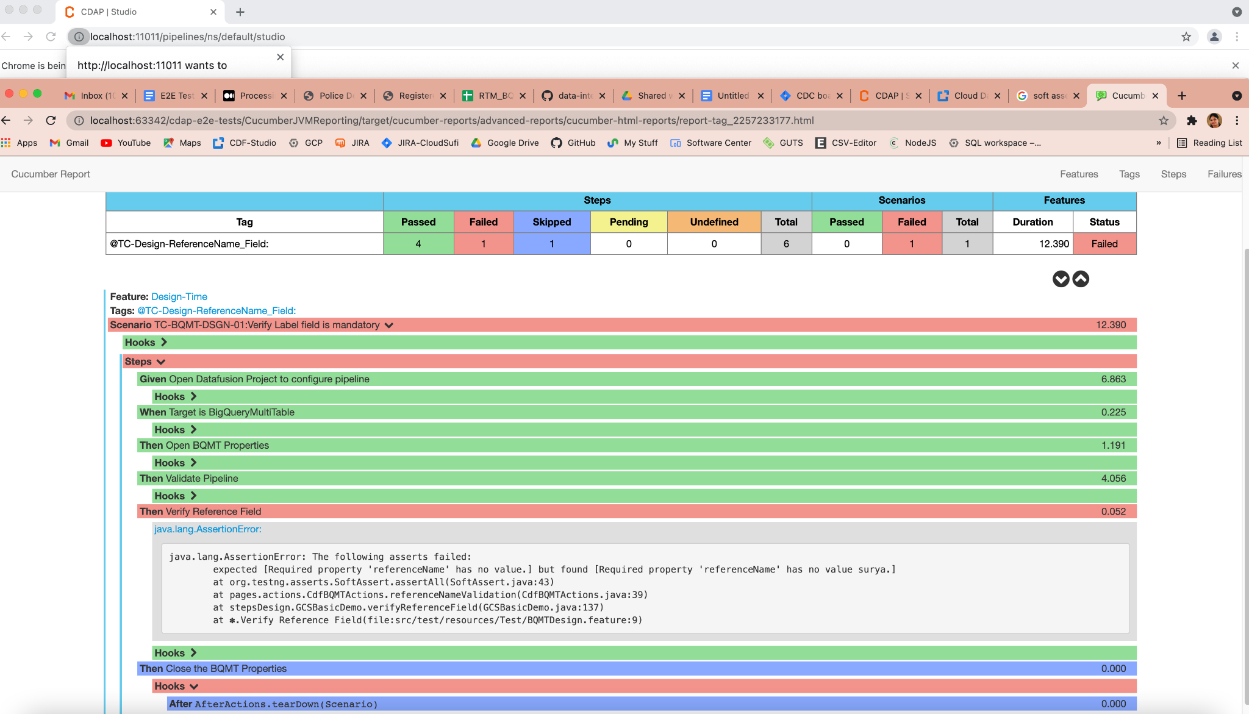

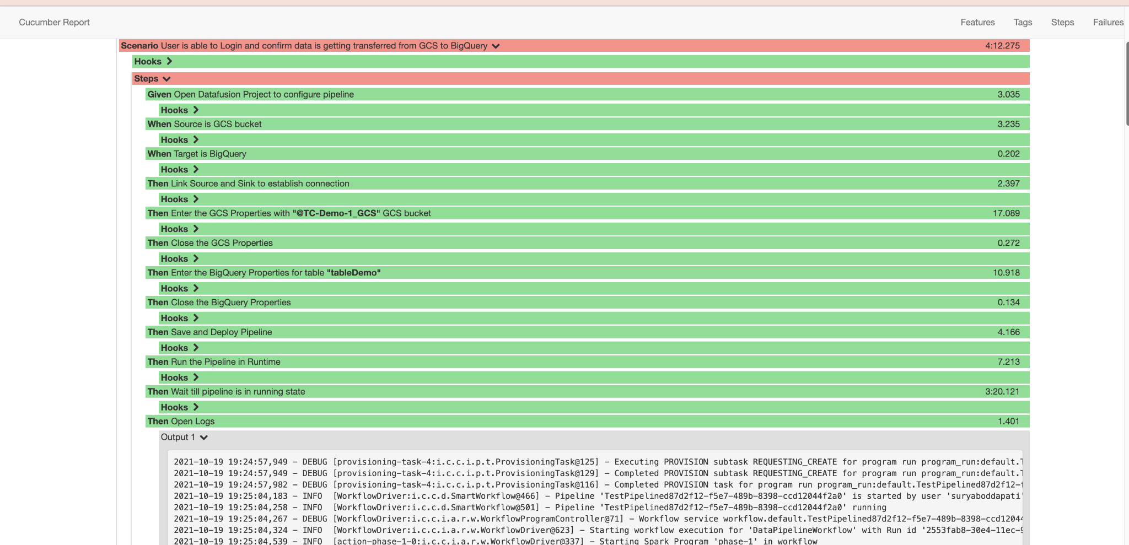

1. **Debug Failures:**

* We may always select the step to be executed in Debug mode. If there are test failures we can figure out what went wrong.

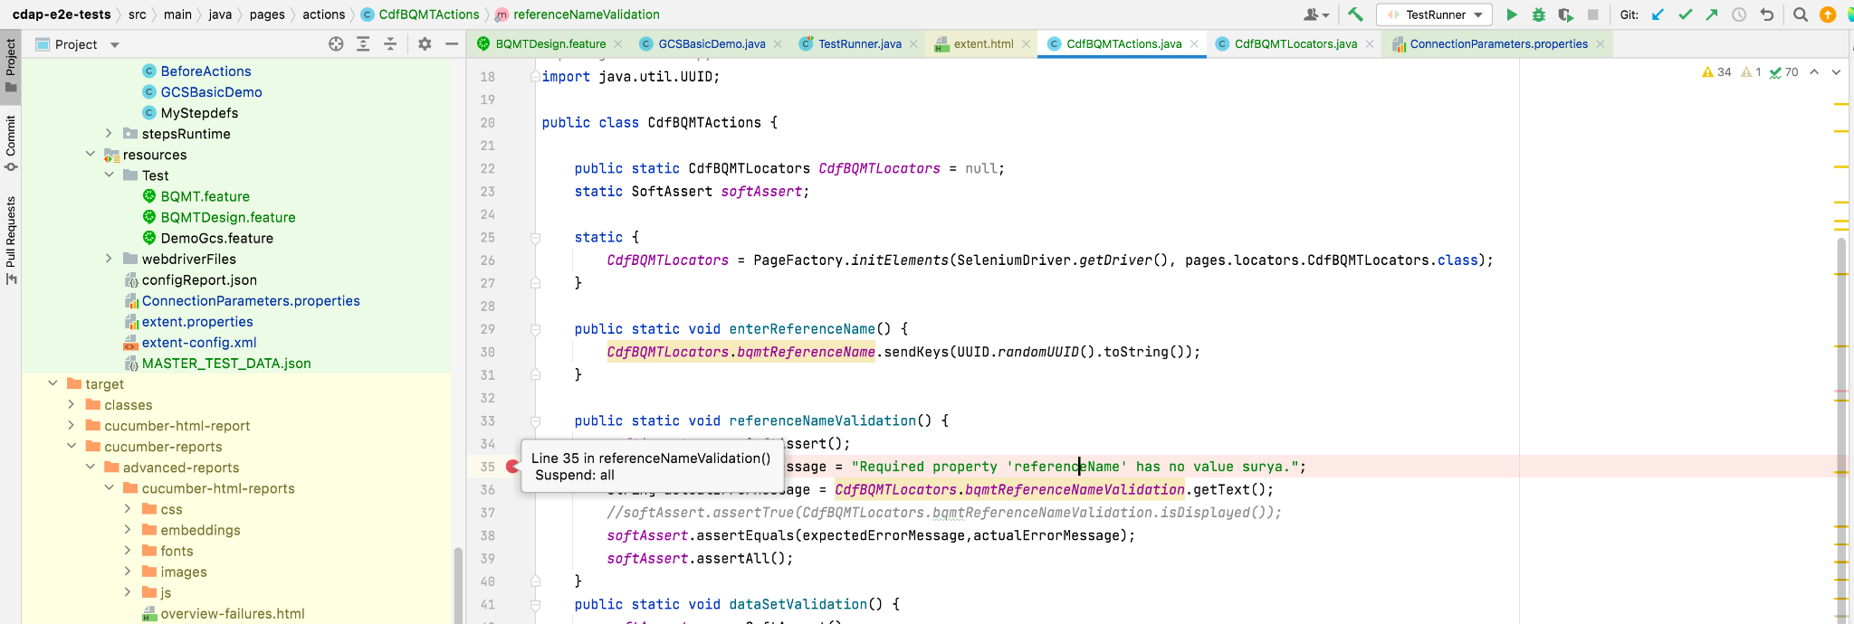

1. **Running the Test case:**

Run the project maven by using ***mvn verify -P e2e-tests*** command. For all the failed results.

1. In the console we can see the below screenshot in execution from maven displaying the results.
2. We can see Test cases failed from the report.
3. We can check with the Logs and Failed screenshot in the report.

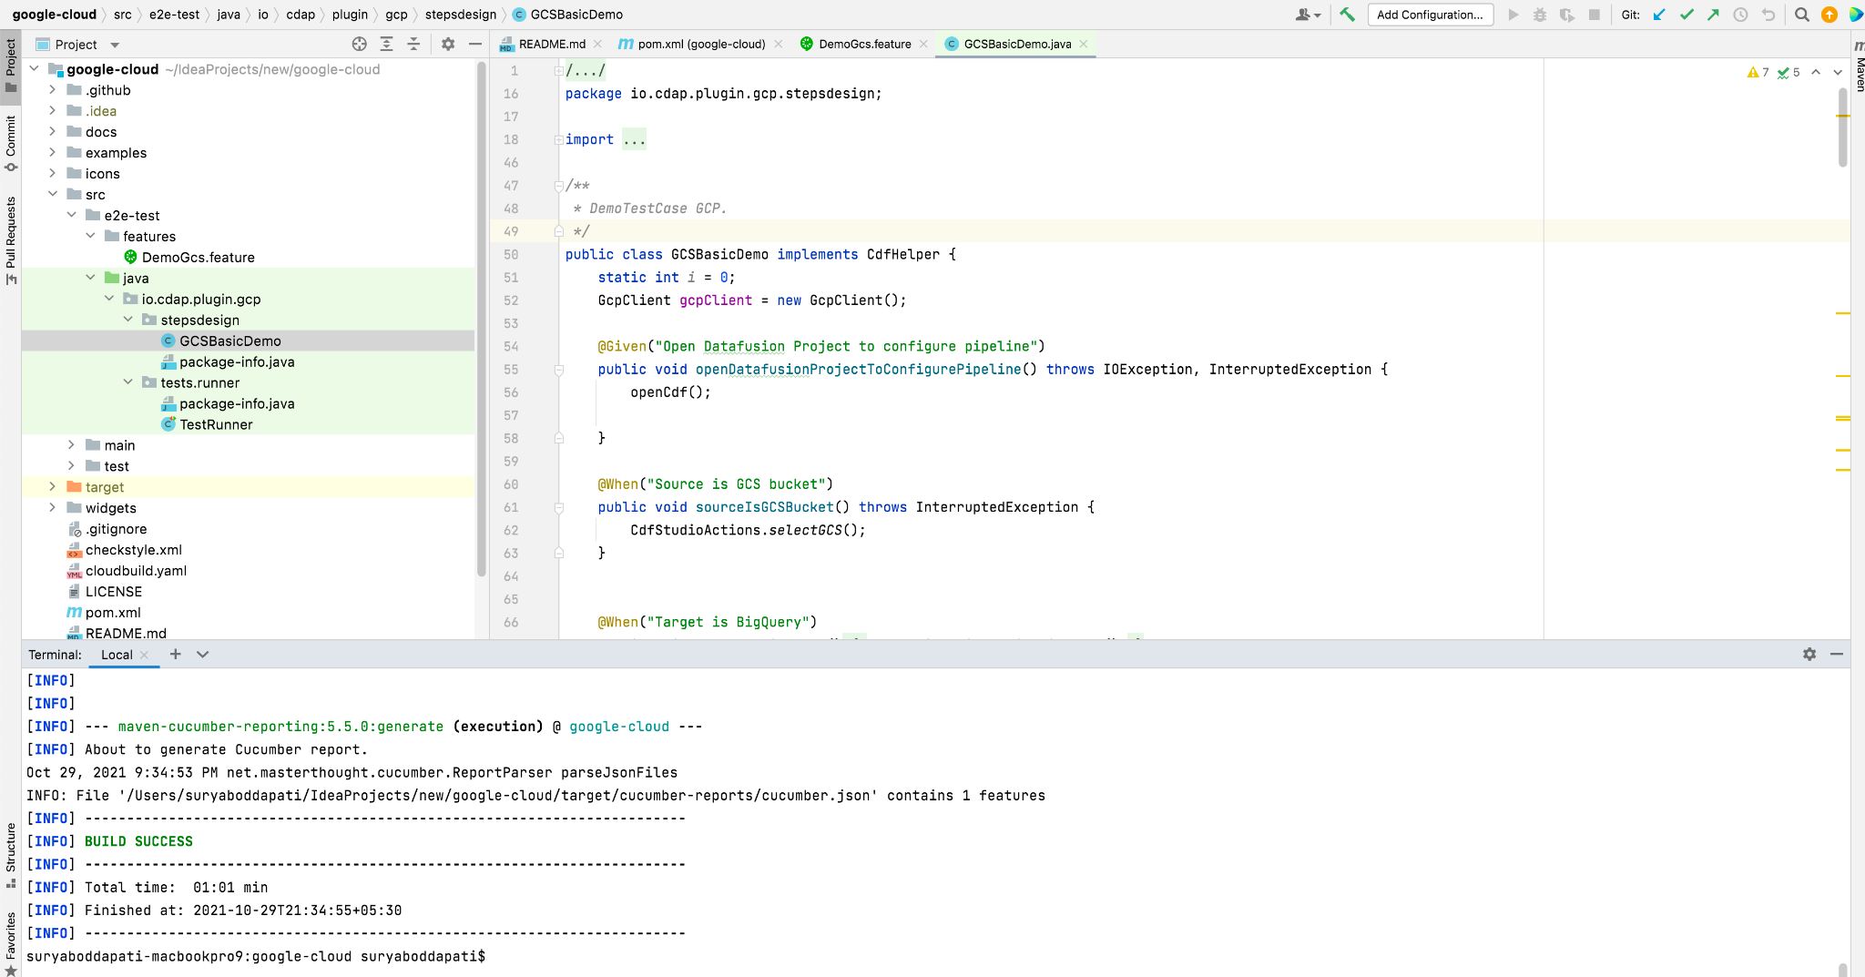

1. **Test Runner:**

* We can run the feature file and execute from the Test runner. Open the Test runner file and give the feature file to be executed.
* The Test Runner file has glue and tags configurations that describe the location and path of the step definition file and tags which are defined in the feature file. It can be specified like below.

glue = {"io.cdap.plugin.gcp.stepsdesign", "stepsdesign"},

tags = {"@BQMT"},

